1 ) What is Exploratory Testing?

Exploratory testing is a type of is testing where tester test software without manner way

2 ) What is traceability matrix?

Test conditions should be able to be linked back to their sources in a test basis this ia known as a traceability matrix

3 ) What is Boundary value testing?

Boundary testing is a black-box testing technique that software developers often use to check the errors at the boundaries or extreme ends of a given input domain. An input domain comprises all the possible inputs available in a software program

4 ) What is Equivalence partitioning testing?

equivalence partitioning is a software testing technique that divides that input and output data of the software unit into partitions of data from which testcase can be derived

5 ) What is Integration testing?

Integration testing is a level of software testing process where individual units are are combined and tested as a group

6 ) What determines the level of risk?

Risk - A factor that could result in future negative consequences usually expressed as risk.

7 ) What is Alpha testing?

Alpha testing is a one type of user acceptance testing (UAT) or internal acceptance testing conducted by the testing team at the end of the developers site

8 ) What is beta testing?

It is also known as a beta site testing or field testing or site testing. Here set of potential end use test a stable version of the application

9 ) What is component testing?

component testing is also known as a unit testing

And a unit is the smallest testable part of the system.

* Component testing is the testing of individual software components
* Sometimes known as a module testing and program testing
* It is typically written and run by the software developer

10 ) What is functional system testing?

Testing based on analysis of the specification of a component or system

11 ) What is Non-Functional Testing?

Testing the attributes of a component or system that do not relate to functionality

12 ) What is GUI Testing?

Graphical user interface (GUI) testing is a process of testing systems GUI under test. It involves buttons, menu bar, like button, hadder etc.

13 ) What is Adhoc testing?

Adhoc testing is an informal testing type with aim to break the system

Types of adhoc testing

* Buddy testing
* Pair testing
* Monkey testing

14 ) What is load testing?

In load testing gradually increasing the load on the software then check speed of software

15 ) What is stress Testing?

Suddenly increasing and decreasing the load on software and check speed of software

16 ) What is white box testing and list the types of white box testing?

Testing based on an analysis of the internal structure of component or system. It is also known as structure based testing, glass testing and open box testing.

* Unit testing
* Integration testing
* System testing

17 ) What is black box testing? What are the different black box testing techniques?

Testing either functional or non functional, without reference to the internal structure of the component or system. It is also known as a specification based testing technique.

There are four techniques of black box testing

* Equivalence partitioning
* Boundary value analysis
* Decision table
* State transition testing

18 ) Mention what are the categories of defects?

19 ) Mention what bigbang testing is?

In big bang integration, all the modules are first required to be completed and then integrated. After integration, testing is carried out on the integrated unit as a whole. It is different from system testing as here we focus testing on the interfacing/communication between the modules

20 ) What is the purpose of exit criteria?

Exit criteria is used to determine whether a given test activity has been completed or not.

* Exit criteria define the items that must be concluded

21 ) When should "Regression Testing" be performed?

regression testing is the testing to re- runs functional and non-functional test to ensure that the a software application works as changes in code, update, improvement

23 ) Difference between QA v/s QC v/s Tester

| QA | QC | Tester |
| --- | --- | --- |
| * It is subset of STLC * Preventive activity * Process oriented activity * Focuses on productive rather than conducting actual testing * Quality Assurance | * It is subset of QA * Corrective process * Product oriented * Focuses on actual testing by executing software with intend to identify bug * Quality Control | * Testing is subset of QC * Preventive process * Product oriented * Focuses on actual testing |

24 ) Difference between Smoke and Sanity?

| Smoke testing | Sanity testing |
| --- | --- |
| * Smoke testing is usually documented or scripted * Smoke testing is lille general health checkup * Smoke testing exercises the whole system from end to end * Use for test critical functionality of program * Performed by developer and tester | * Sanity testing is non performed or unscripted * Sanity testing is like specialized health checkup * Sanity testing exercises only particular component of the entire system * Use for test new functionality of program * Performed by tester |

25 ) Difference between verification and Validation

| Verification | Validation |
| --- | --- |
| * Depends on documentation * Verification done before coding * Are we building the right product * Process oriented approach * Example   + HLD   + LLD   + SRS   + URS   + CRS   + BRS | * Depends on developed software * Validation done after coding * Are we building product right * Product oriented approach * Example   + Unit testing   + Integration testing   + System testing   + UAT testing   + White box testing   + Black box testing |

26 ) Explain types of Performance testing.

* Load testing

In load testing gradually increasing the load on the software then check speed of software

* Stress testing

Suddenly increasing and decreasing the load on software and check speed of software

* Volume testing

How much data able to handle by software

27 ) What is Error, Defect, Bug and failure?

Error - An error is a mistake made by human that leads to discrepancy between the actual and the expected result

Defect - A defect is a problem in the functioning of a software system during testing

Bug - A bug is a flaw in a software system that causes the system to behave in an unintended manner

28 ) Difference between Priority and Severity

| Severity | Priority |
| --- | --- |
| * Severity is a absolute * severity is customer focus * It impacts on defect * There are 5 types of severity * Critical * Major * Moderate * Minor * cosmetic | * Priority is a relative * Priority is a business focus * It resolves the defect * There are four types of priority * Low * High * Medium * critical |

29 ) What is Bug Life Cycle?

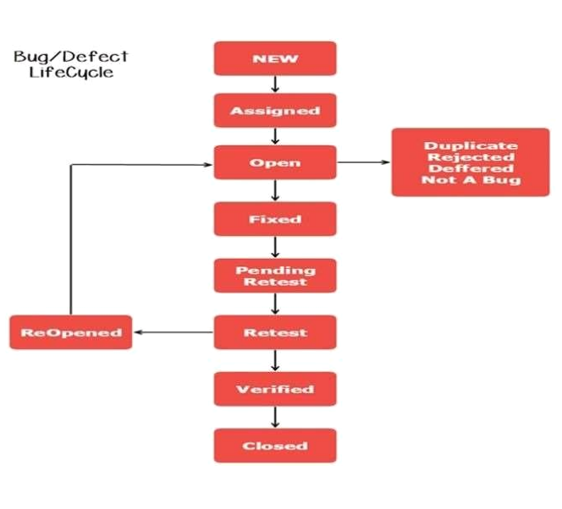

New - When a new defect is logged and posted for the first time.

It is assigned a status as new

Assigned - Once the bug is posted by the tester, the lead of the

tester approves the bug and assigns the bug to the developer

team

Open - The developer starts analyzing and works on the defect

Fix

Fixed - When a developer makes a necessary code change and

verifies the change, he or she can make bug status as “Fixed.”

Pending retest - Once the defect is fixed the developer gives a

particular code for testing the code to the tester. Since the

software testing remains pending from the testers end, the status

assigned is “pending retest.”

Retest - Tester does the retesting of the code at this stage to

check whether the defect is fixed by the developer or not and

changes the status to “Re-test.”

Verified - The tester re-tests the bug after it got fixed by the

developer. If there is no bug detected in the software, then the

bug is fixed and the status assigned is“verified.”

Reopened - If the bug persists even after the developer has fixed

the bug, the tester changes the status to “reopened”. Once again

the bug goes through the life cycle.Closed: If the bug is no

longer exists then tester assigns the status “Closed.” Duplicate:

If the defect is repeated twice or the defect corresponds to the

same concept of the bug, the status is changed to “duplicate.”

Rejected - If the developer feels the defect is not a genuine defect

then it changes the defect to “rejected.”

Deferred - If the present bug is not of a prime priority and if it is

expected to get fixed in the next release, then status “Deferred” is

assigned to such bugs

Not a bug - If it does not affect the functionality of the application

then the status assigned to a bug is “Not a bug”.

30 ) Explain the difference between Functional testing and NonFunctional testing

| Functional testing | Non functional testing |
| --- | --- |
| * Testing based on analysis of the specification of the functionality of a component or system * Functional testing should be executed first * Easy to do manual testing * Functional testing how product does * Types of functional testing   + Unit testing   + Smoke testing   + Sanity testing   + Integration testing   + White box testing   + User acceptance testing   + Regression testing | * Testing the attributes of a component or system that do not relate to functionality * It should be performed after functional   testing   * Hard to do manual testing * Non functional testing describe how good product work * Types of non functional testing   + Stress testing   + Load testing   + Performance testing   + Security testing |